1. Write a MongoDB query to display all the documents in the collection restaurants

db.samplerestaurant.find()

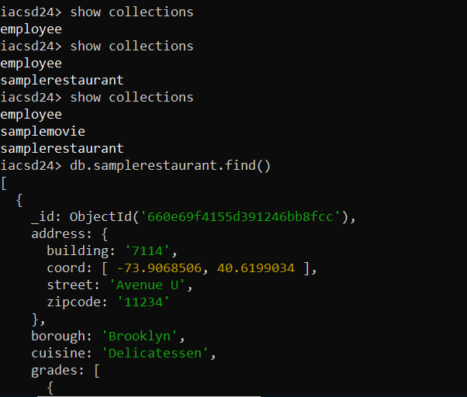

2. Write a MongoDB query to display the fields restaurant_id, name, borough and cuisine for

all the documents in the collection restaurant.

db.samplerestaurant.find({},{name:1,borough:1,cuisine:1})

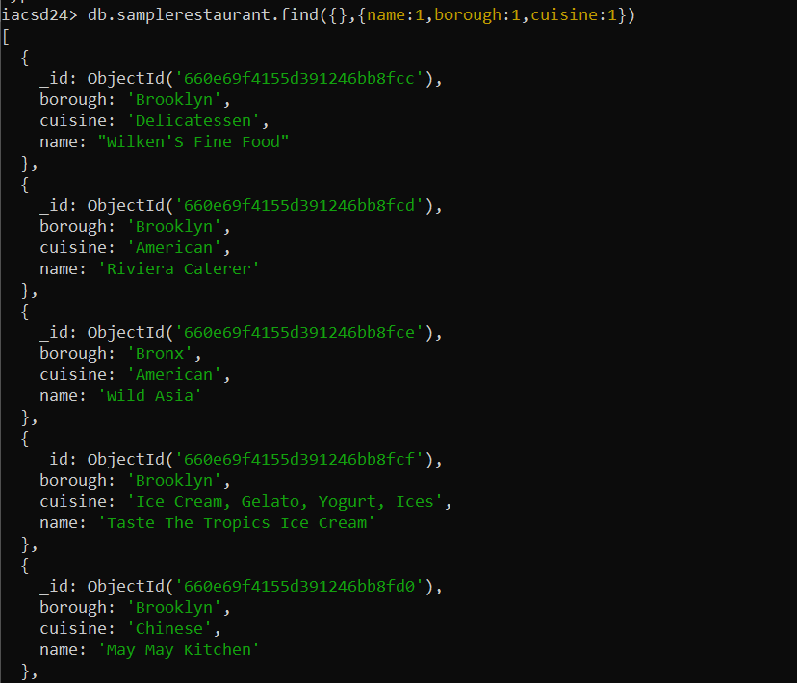

3. Write a MongoDB query to display the fields restaurant_id, name, borough and cuisine,

but exclude the field _id for all the documents in the collection restaurant.

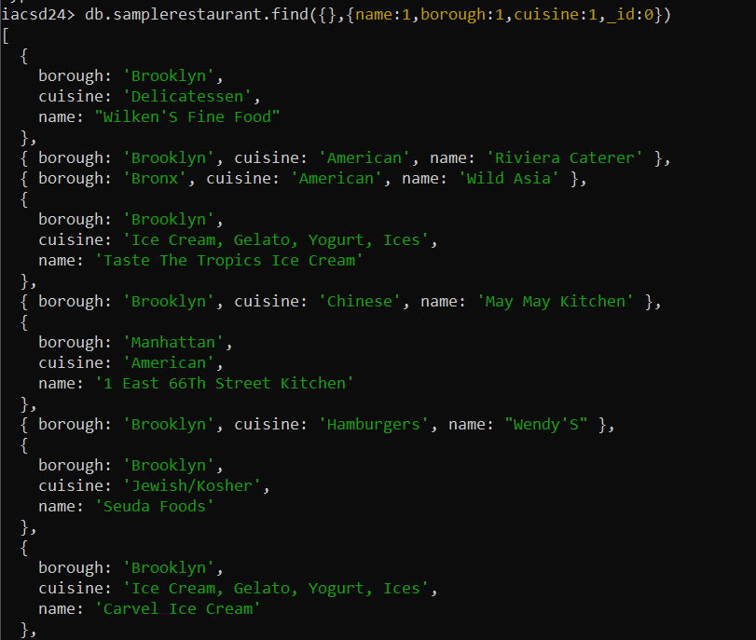

4. Write a MongoDB query to display the fields restaurant_id, name, borough and zip code,

but exclude the field _id for all the documents in the collection restaurant.

db.samplerestaurant.find({},{name:1,borough:1,zipcode:1,_id:0})

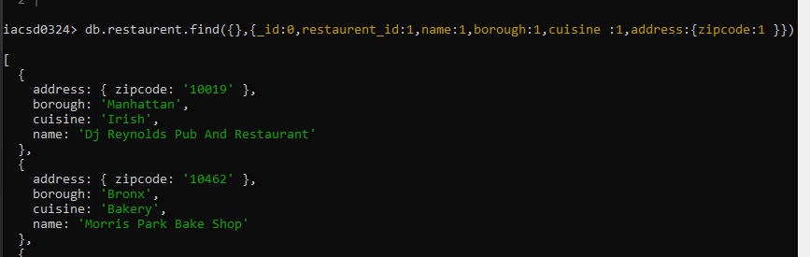

5. Write a MongoDB query to display all the restaurant which is in the borough Bronx

db.samplerestaurant.find({borough:'Bronx'},{name:1,borough:1,_id:0})

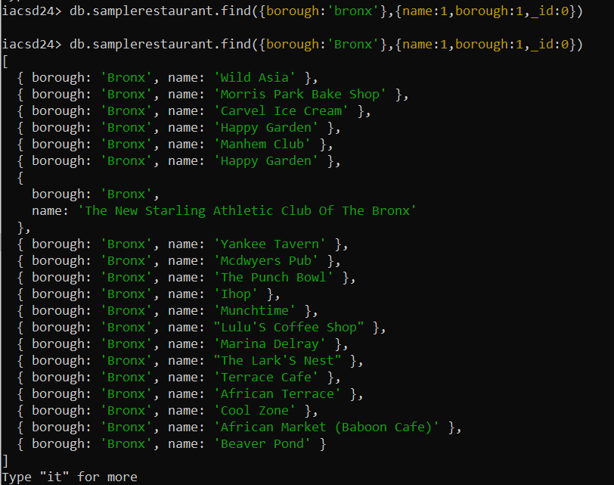

6. Write a MongoDB query to display the first 5 restaurant which is in the borough Bronx.

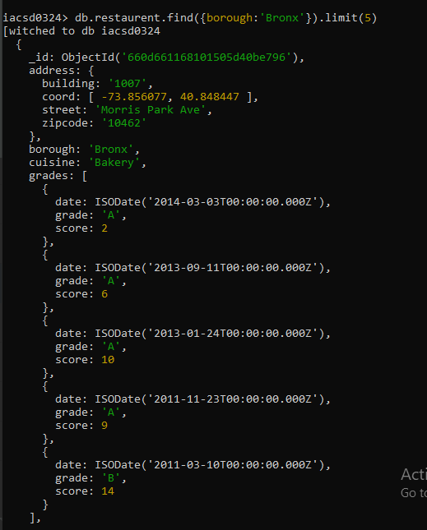

7.Write a MongoDB query to display the next 5 restaurants after skipping first 5 which are in

the borough Bronx.

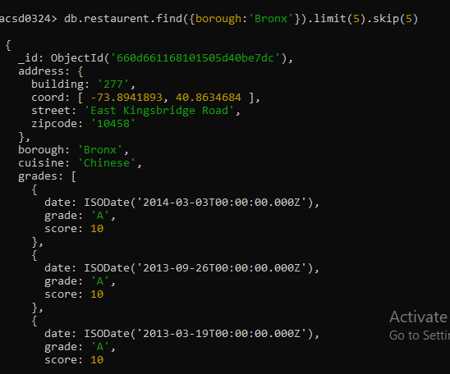

8. Write a MongoDB query to find the restaurants who achieved a score more than 90.

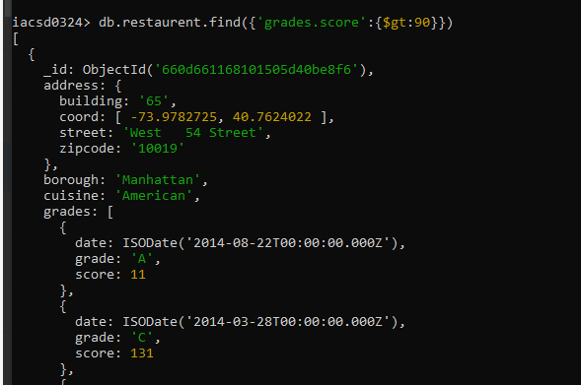

9. Write a MongoDB query to find the restaurants that achieved a score, more than 80 but

less than 100.

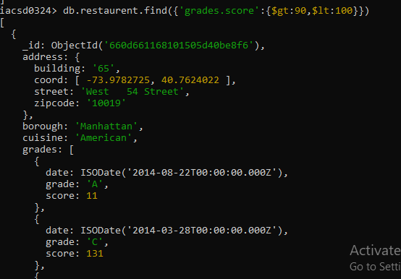

10. Write a MongoDB query to find the restaurants which locate in latitude value less than -

95.754168.

db.restaurant.find({'address.coord.1':{$lt:95.754168}},{name:1,'address.coord':1,_id:0})

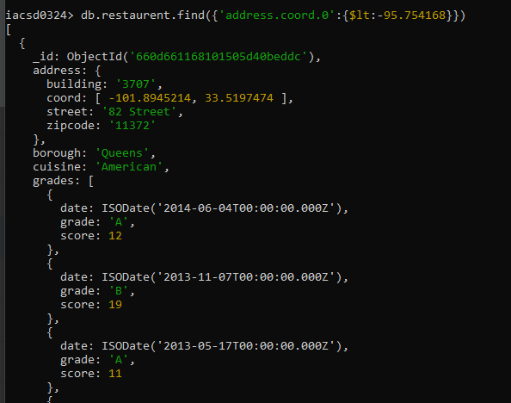

11. Write a MongoDB query to find the restaurants that do not prepare any cuisine of

'American' and their grade score more than 70 and latitude less than -65.754168.

→

db.restaurant.find({cuisine : {$nin :['American']},

'grades.score' : {$gt:70},

'address.coord.0':{$lt : -65.754168}},

{name : 1,'address.coord':1,'grades.score':1, _id:0})

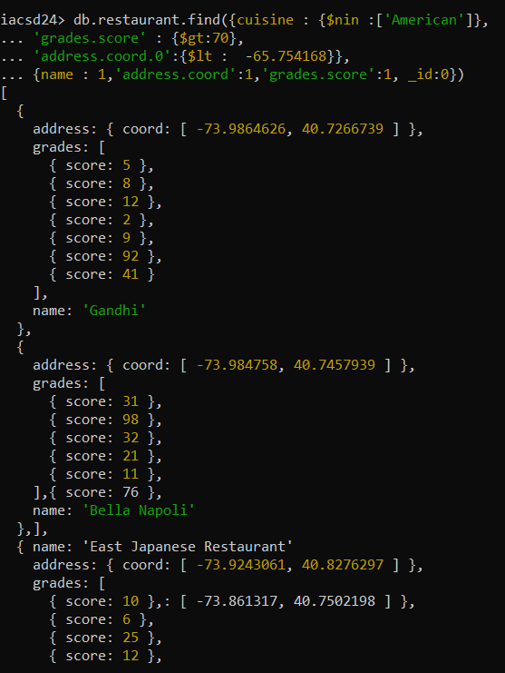

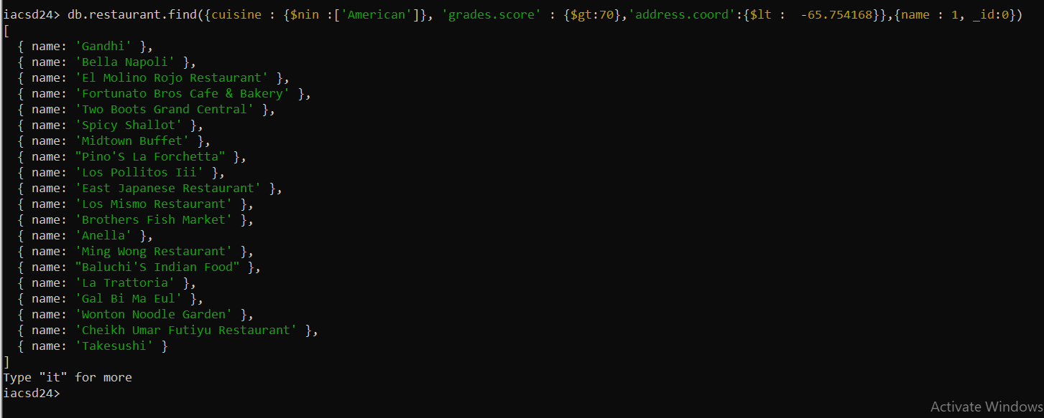

12. Write a MongoDB query to find the restaurants which do not prepare any cuisine of

'American' and achieved a score more than 70 and located in the longitude less than -

65.754168.

→

db.restaurant.find({cuisine : {$nin :['American']},

'grades.score' : {$gt:70},

'address.coord.1':{$lt : 65.754168}},

{name : 1,'address.coord':1,'grades.score':1, _id:0})

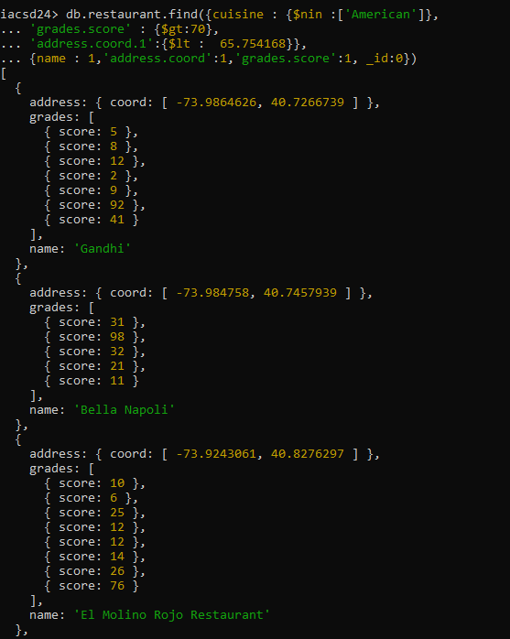

db.restaurant.find({cuisine : {$nin :['American']},

'grades.score' : {$gt:70},

'address.coord.1':{$lt : -65.754168}},

{name : 1,'address.coord':1,'grades.score':1, _id:0})

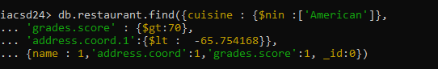

13. Write a MongoDB query to find the restaurants which do not prepare any cuisine of

'American ' and achieved a grade point 'A' not belongs to the borough Brooklyn. The

document must be displayed according to the cuisine in descending order.

→

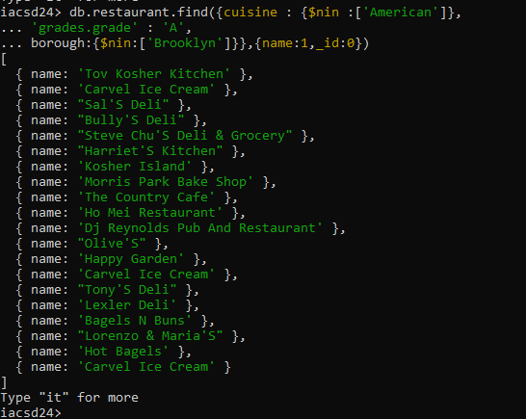

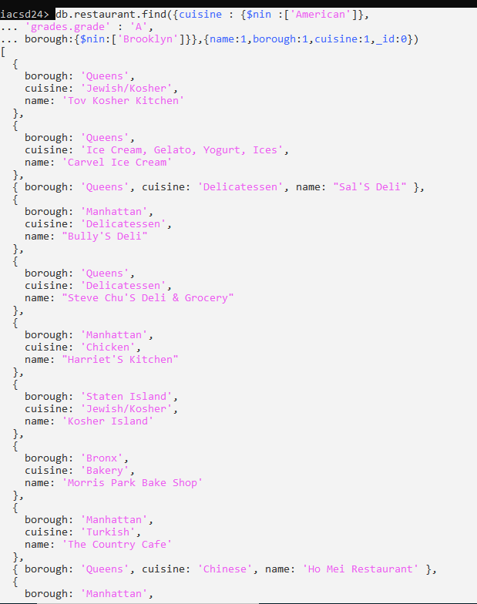

14. Write a MongoDB query to find the restaurant Id, name, borough and cuisine for those

restaurants which contain 'Wil' as first three letters for its name.

→

db.restaurant.find({name:/^wil/i},{name : 1, borough : 1, cuisine : 1})

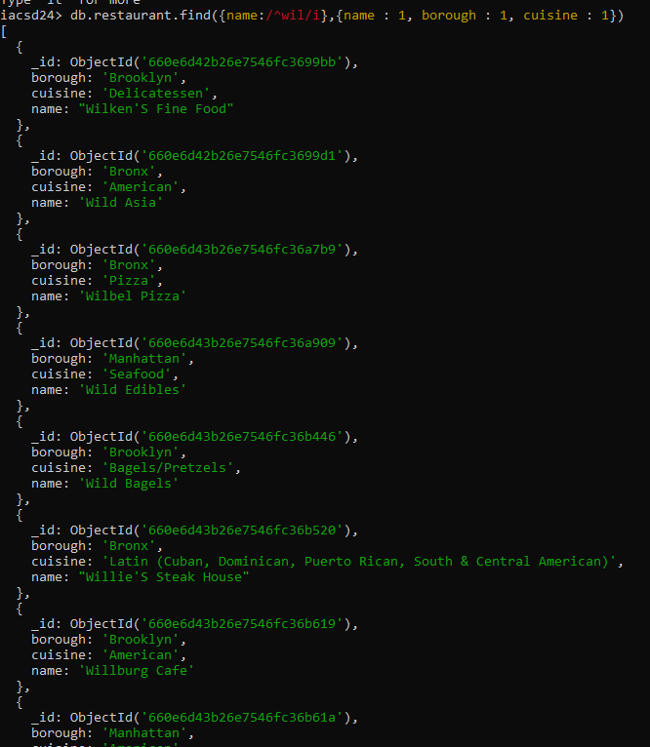

15. Write a MongoDB query to find the restaurant Id, name, borough and cuisine for those

restaurants which contain 'ces' as last three letters for its name.

→

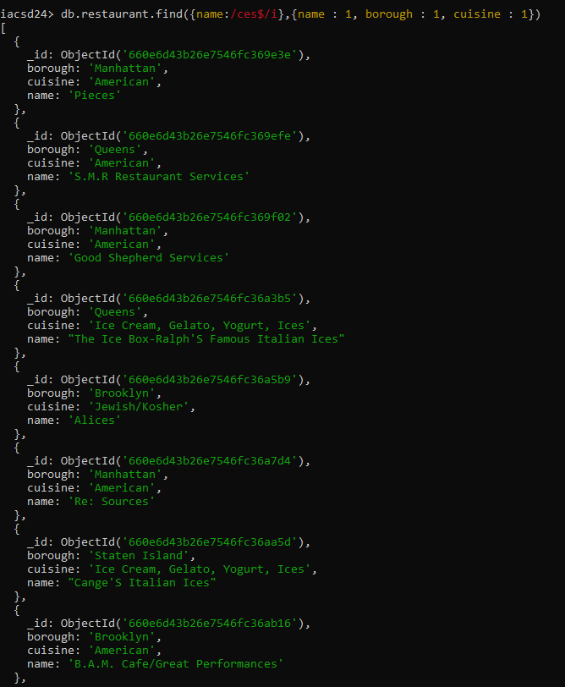

16. Write a MongoDB query to find the restaurant Id, name, borough and cuisine for those

restaurants which contain 'Reg' as three letters somewhere in its name.

db.restaurant.find({name:/reg/i},{name : 1, borough : 1, cuisine : 1})

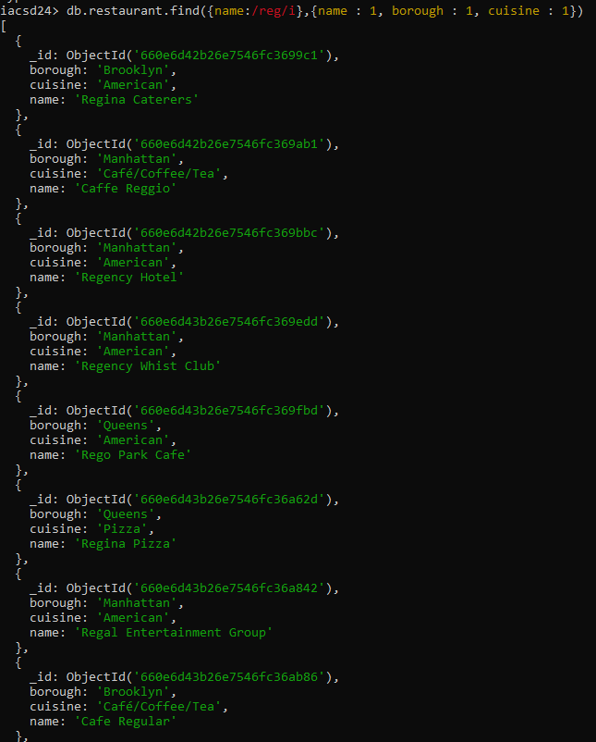

17. Write a MongoDB query to find the restaurants which belong to the borough Bronx and

prepared either American or Chinese dish.

db.restaurant.find({borough:'Bronx',cuisine:{$in:['American','Chinese']}},{name:1,borough:1,cuisine:1,_id:0})

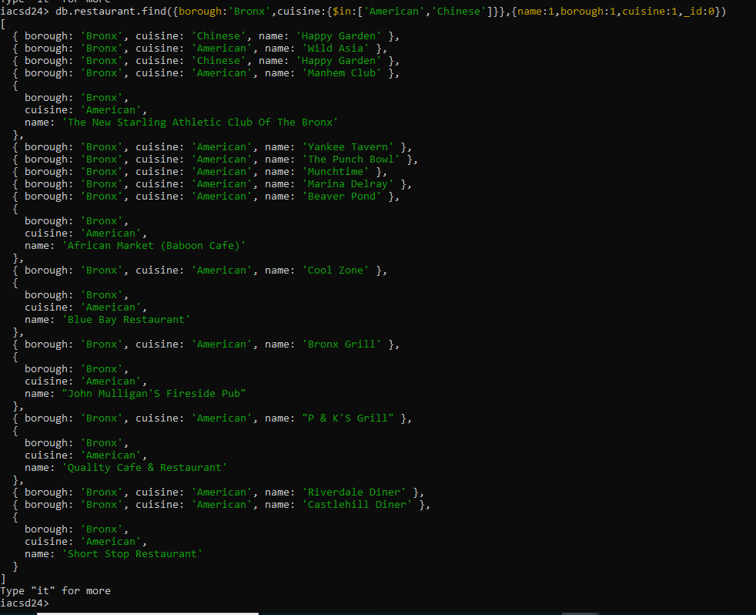

18. Write a MongoDB query to find the restaurant Id, name, borough and cuisine for those

restaurants which belong to the borough Staten Island or Queens or Bronxor Brooklyn

db.restaurant.find({$or:[{borough:{$in:['Staten Island','Queens','Bronx','Brooklyn']}}]},{name:1,borough:1,cuisine:1})

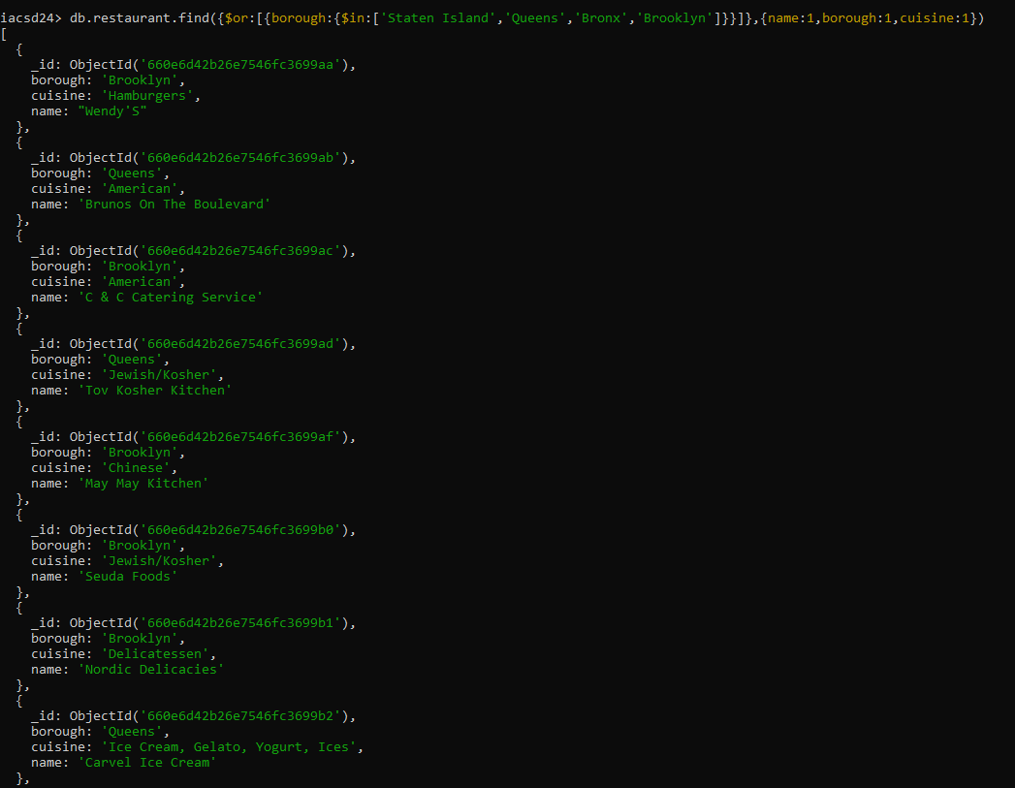

19. Write a MongoDB query to find the restaurant Id, name, borough and cuisine for those

restaurants which are not belonging to the borough Staten Island or Queens or Bronxor

Brooklyn.

db.restaurant.find({$or:[{borough:{$nin:['Staten Island','Queens','Bronx','Brooklyn']}}]},{name:1,borough:1,cuisine:1})

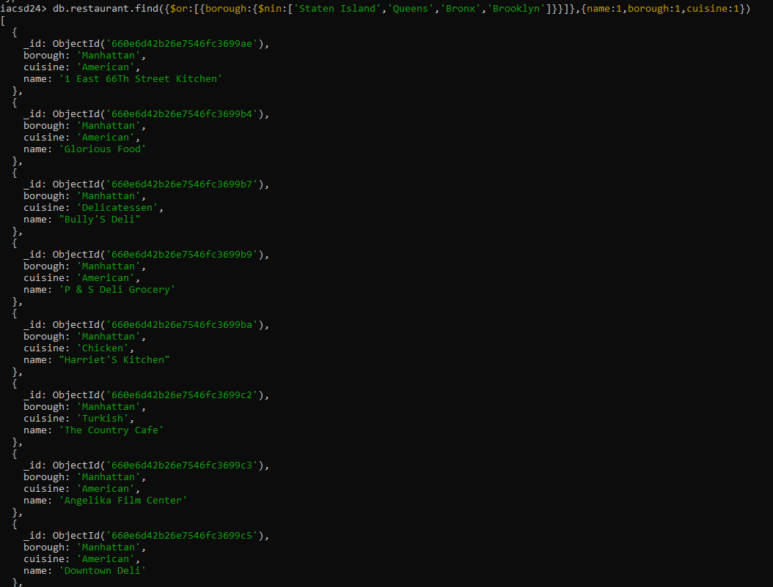

20. Write a MongoDB query to find the restaurant Id, name, borough and cuisine for those

restaurants which achieved a score which is not more than 10.

**db.restaurant.find({'grades.score':{$not:{$gt:10}}},{name:1,borough:1,cuisine:1})**

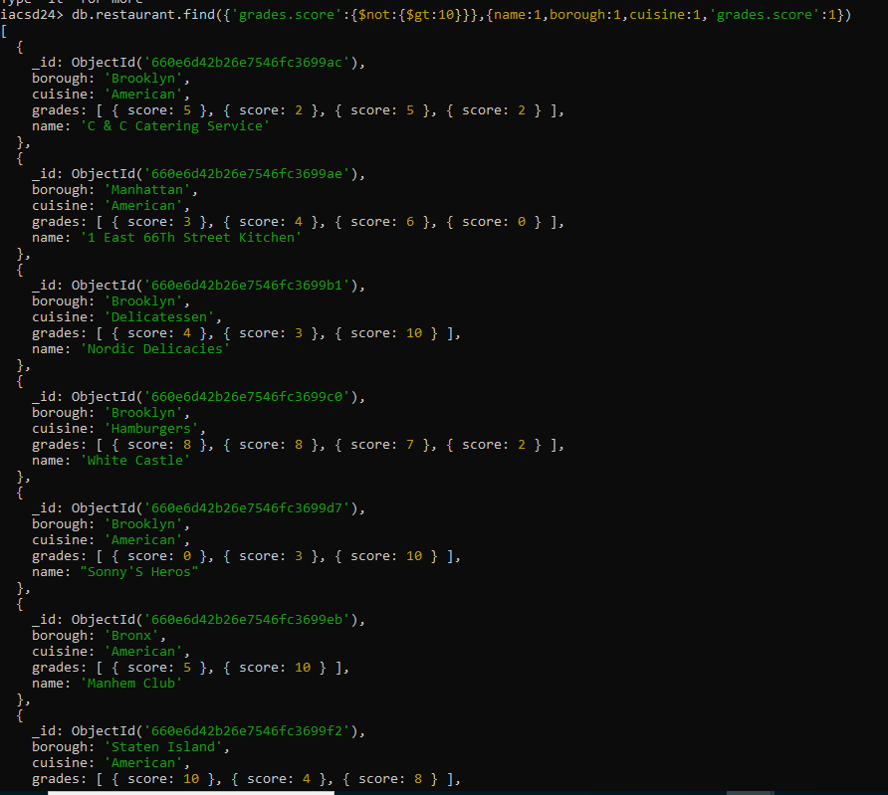

21. Write a MongoDB query to find the restaurant Id, name, borough and cuisine for those

restaurants which prepared dish except 'American' and 'Chinees' or restaurant's name begins

with letter 'Wil'.

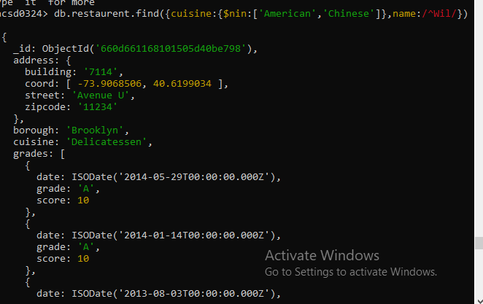

22. Write a MongoDB query to find the restaurant Id, name, and grades for those restaurants

which achieved a grade of "A" and scored 11 on an ISODate "2014-08-11T00:00:00Z"

among many of survey datesSO

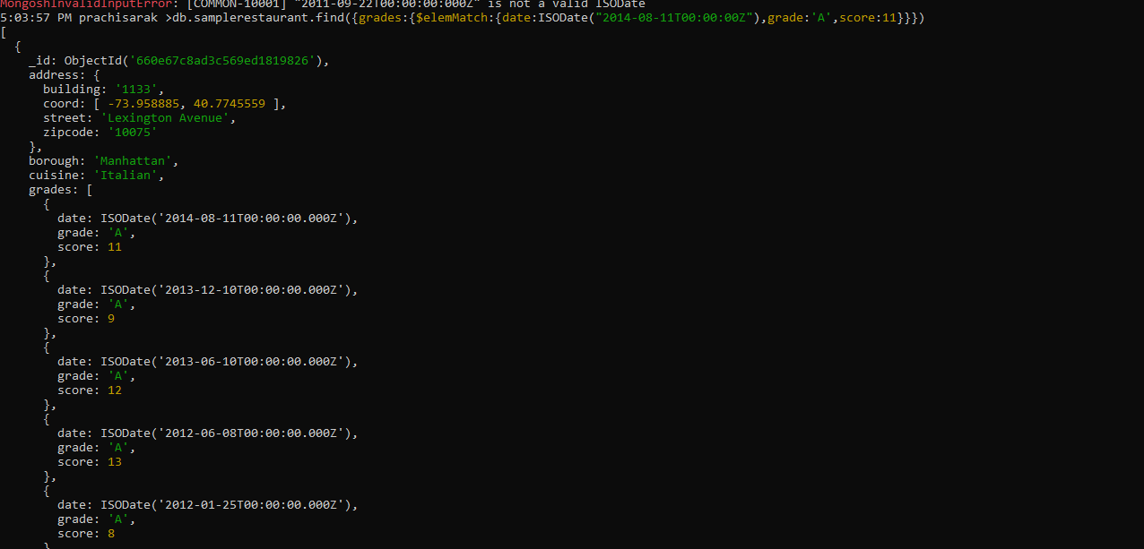

23. Write a MongoDB query to find the restaurant Id, name and grades for those restaurants

where the 2nd element of grades array contains a grade of "A" and score 9 on an ISODate

"2014-08-11T00:00:00Z".

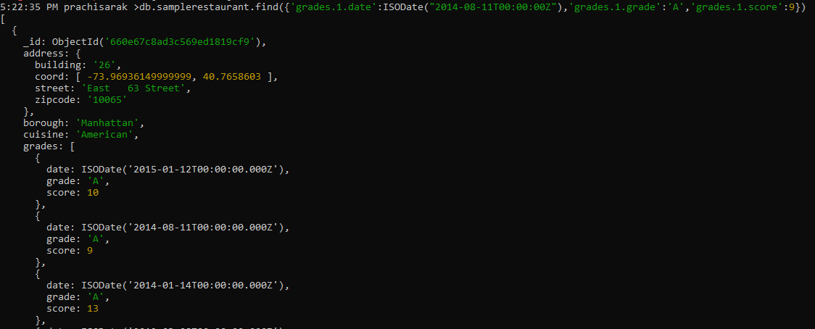

24. Write a MongoDB query to find the restaurant Id, name, address and geographical

location for those restaurants where 2nd element of coord array contains a value which is

more than 42 and upto 52

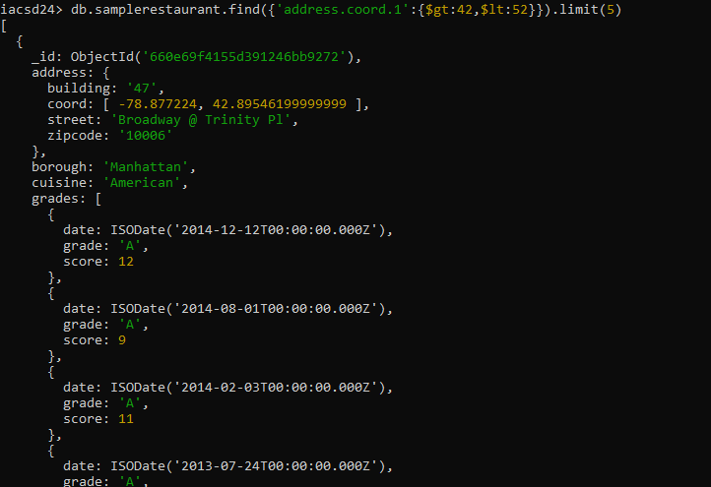

25. Write a MongoDB query to arrange the name of the restaurants in ascending order along

with all the columns.

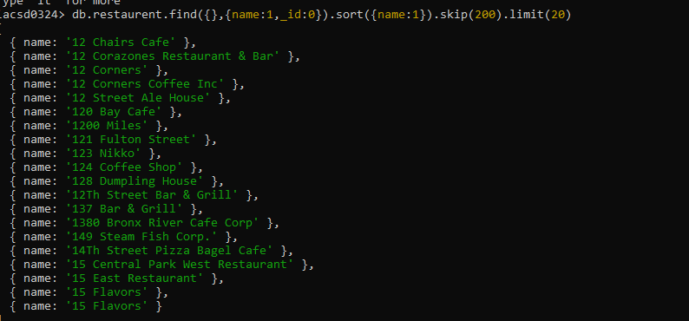

26. Write a MongoDB query to arrange the name of the restaurants in descending along with

all the columns.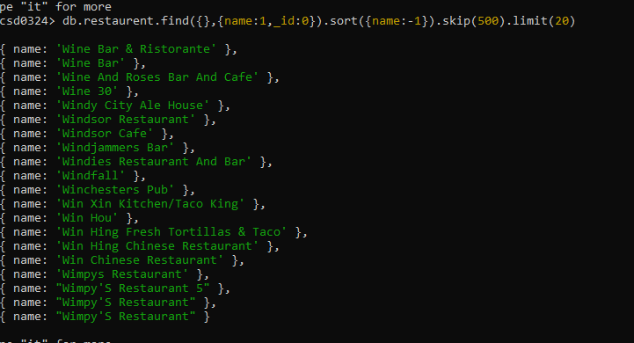

27. Write a MongoDB query to arranged the name of the cuisine in ascending order and for

that same cuisine borough should be in descending order.

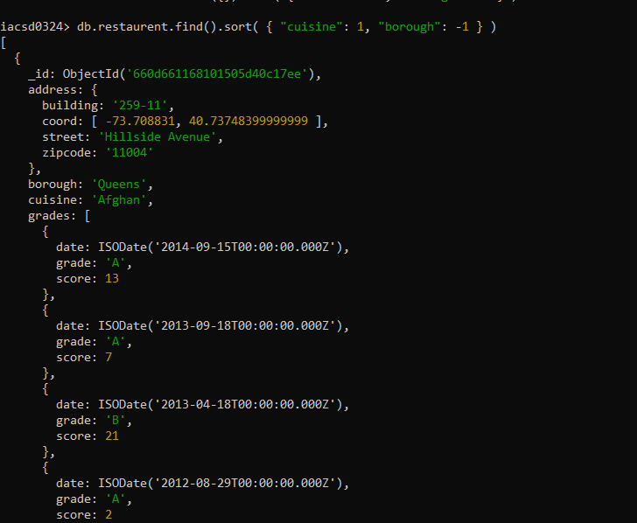

28. Write a MongoDB query to know whether all the addresses contain the street or not.

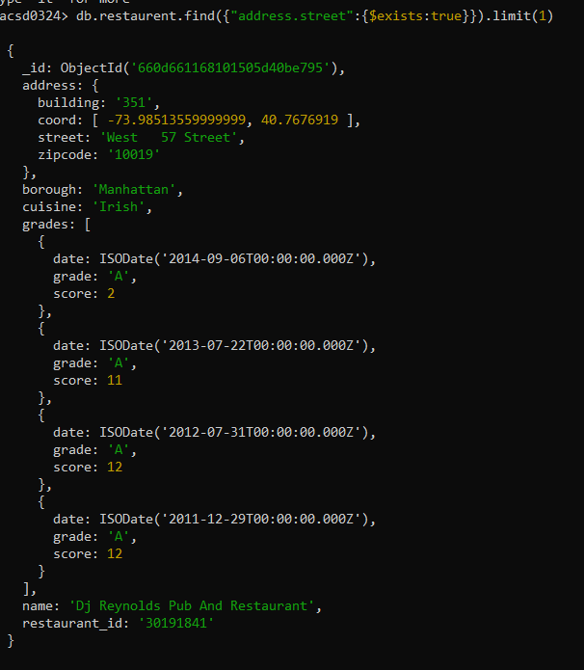

29. Write a MongoDB query which will select all documents in the restaurants collection

where the coord field value is Double.

30. Write a MongoDB query which will select the restaurant Id, name and grades for those

restaurants which returns 0 as a remainder after dividing the score by 7.

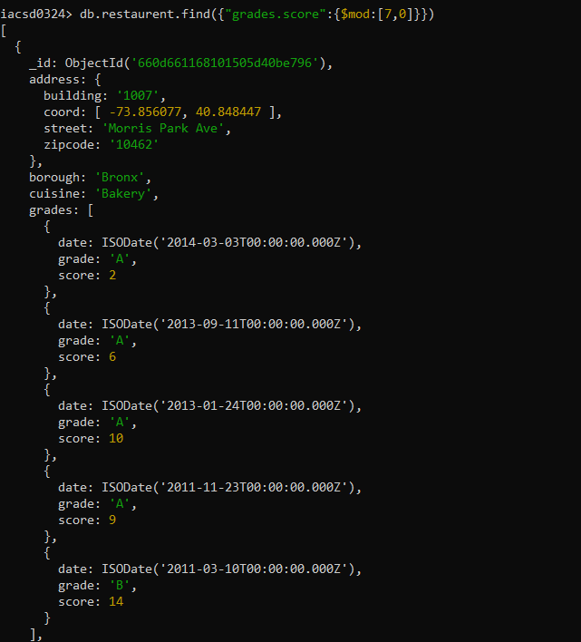

31. Write a MongoDB query to find the restaurant name, borough, longitude and attitude and

cuisine for those restaurants which contains 'mon' as three letters somewhere in its name.

32. Write a MongoDB query to find the restaurant name, borough, longitude and latitude and

cuisine for those restaurants which contain 'Mad' as first three letters of its name.

